GoFundMe Fundraising Campaign
Setting up a GoFundMe fundraising campaign was easy. It took about an hour for everything, including writing the project statement (pinning down my son to write the statement, and then me doing a little edit to make sure it included everything). I connected it to my facebook page so it reaches more people.
What you should have before you begin:
- Statement with Funding Goal
- Photo or video
- Contacts list (or facebook login)
- SSN and Bank Account Number to set up your WePay account

- Go to www.gofundme.com
- Click the ‘Sign Up Free’ button
- Create login (I used my facebook login) and choose campaign type (we chose personal )
- Set your Goal Amount.
- Attach a photo or video
- Set your Zip code
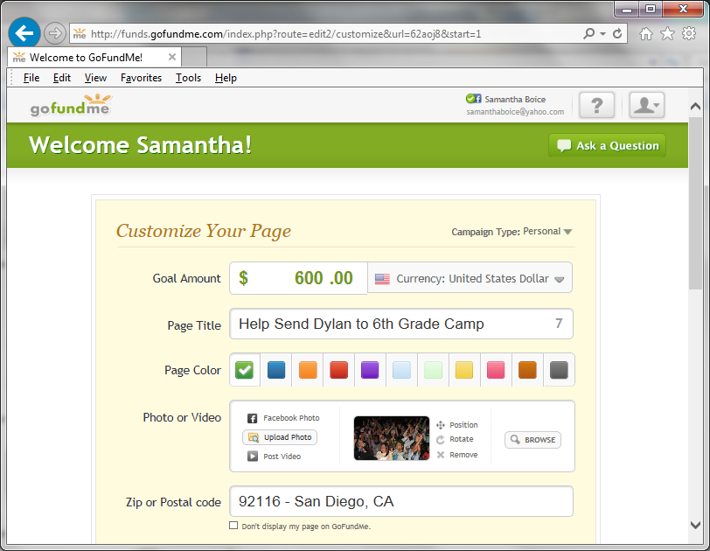
- Add your Project Description (here is Dylan’s), and click Continue.
Here’s Dylan’s Description:
My name is Dylan Boice-Hunt and I’m a 6th grader at Roosevelt IB Middle School. I go hiking a lot and I enjoy it very much. At 6th grade camp we will get to go and experience the wilderness. This is not only the first school related outdoor field trip to many but also a week of sleep away camp. I myself have never been to sleep away camp and am looking forward to going, that is if we can raise the money to go.
It would take more than $100,000 to send every kid in the Roosevelt 6th grade to camp. Our school is more than 85% low income so many students have not ever gone on a real outdoor trip like this. The PTSA originally were trying to raise enough to send all 6th graders but, we realize this is a lot of money. Instead we’re going to camp over spring break 3/31 – 4/4/2014 so know not all kids will go. We are trying to raise $33,000 to send 100 kids (camp, insurance and transportation).
Please help me raise enough here for me and a friend to go to 6th Grade Camp. If you are interested in helping out more, you can make a tax-deductible donation directly to the PTSA at http://roosevelt-6th-grade-camp.weebly.com/.

- Now you can share your campaign page, or customize your link and then share.
- The last step is to set up your WePay account. You’ll need to enter your SSN and bank account information. It’s as user friendly as setting up the GoFundMe campaign. Just follow the directions onscreen.

